Data Privacy and Confidentiality Policy
HR Knowledge Hub | HR Policies | Owner: Maria Chen | Last updated: October 30, 2026

Section 1: Executive Summary & Scope
Explains how employee and candidate personal data is collected, stored, and shared, and the obligations employees have when handling confidential HR records. Section 1 (Executive Summary & Scope) applies to HR Policies within HR Knowledge Hub and is maintained by Maria Chen. Defines the operational charter, scope boundaries, and executive accountability.
Operational requirement 1.1: HR records are retained for 7 years after separation, then securely purged. Secondary control 1.2: Access to compensation and medical data is restricted to HR Business Partners and Total Rewards.
- HR records are retained for 7 years after separation, then securely purged.
- Access to compensation and medical data is restricted to HR Business Partners and Total Rewards.
- Section 1 review cadence is tracked by Maria Chen under HR Policies governance.
Control Area | Owner | Target SLA | Verification Status
HR Policies | Maria Chen | 5 business days | Verified
Data Privacy and Confidentia Gate 1 | Maria Chen | 3 business days | Active
Data Privacy and Confidentia Gate 2 | Maria Chen | 10 business days | Monitored
Page 1 of 4 | HR Knowledge Hub | HR Policies | SharePoint Online

Section 2: Architecture & Process Flow
Explains how employee and candidate personal data is collected, stored, and shared, and the obligations employees have when handling confidential HR records. Section 2 (Architecture & Process Flow) applies to HR Policies within HR Knowledge Hub and is maintained by Maria Chen. Maps end-to-end process stages, handoff gates, and system-of-record integrations.
Operational requirement 2.1: Access to compensation and medical data is restricted to HR Business Partners and Total Rewards. Secondary control 2.2: Background check results may not be shared outside the hiring committee.
- Access to compensation and medical data is restricted to HR Business Partners and Total Rewards.
- Background check results may not be shared outside the hiring committee.
- Section 2 review cadence is tracked by Maria Chen under HR Policies governance.
Control Area | Owner | Target SLA | Verification Status
HR Policies | Maria Chen | 5 business days | Verified
Data Privacy and Confidentia Gate 1 | Maria Chen | 3 business days | Active
Data Privacy and Confidentia Gate 2 | Maria Chen | 10 business days | Monitored
Sec-2 | Maria Chen | 3 business days | Stage 2 Verified
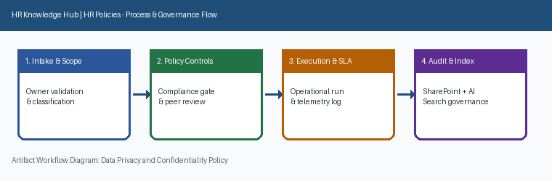
Page 2 of 4 | HR Knowledge Hub | HR Policies | SharePoint Online

Section 3: Governance Standards & Controls
Explains how employee and candidate personal data is collected, stored, and shared, and the obligations employees have when handling confidential HR records. Section 3 (Governance Standards & Controls) applies to HR Policies within HR Knowledge Hub and is maintained by Maria Chen. Establishes mandatory compliance controls, approval thresholds, and audit evidence.
Operational requirement 3.1: Background check results may not be shared outside the hiring committee. Secondary control 3.2: Any suspected data exposure must be reported to IT Security within one business day.
- Background check results may not be shared outside the hiring committee.
- Any suspected data exposure must be reported to IT Security within one business day.
- Section 3 review cadence is tracked by Maria Chen under HR Policies governance.
Control Area | Owner | Target SLA | Verification Status
HR Policies | Maria Chen | 5 business days | Verified
Data Privacy and Confidentia Gate 1 | Maria Chen | 3 business days | Active
Data Privacy and Confidentia Gate 2 | Maria Chen | 10 business days | Monitored
Sec-3 | Maria Chen | 10 business days | Stage 3 Verified
Page 3 of 4 | HR Knowledge Hub | HR Policies | SharePoint Online

Section 4: Appendix, Lineage & Sign-off
Explains how employee and candidate personal data is collected, stored, and shared, and the obligations employees have when handling confidential HR records. Section 4 (Appendix, Lineage & Sign-off) applies to HR Policies within HR Knowledge Hub and is maintained by Maria Chen. Records document lineage, governance metadata, version history, and owner sign-off.
Operational requirement 4.1: Any suspected data exposure must be reported to IT Security within one business day. Secondary control 4.2: HR records are retained for 7 years after separation, then securely purged.
- Any suspected data exposure must be reported to IT Security within one business day.
- HR records are retained for 7 years after separation, then securely purged.
- Section 4 review cadence is tracked by Maria Chen under HR Policies governance.
Control Area | Owner | Target SLA | Verification Status
HR Policies | Maria Chen | 5 business days | Verified
Data Privacy and Confidentia Gate 1 | Maria Chen | 3 business days | Active
Data Privacy and Confidentia Gate 2 | Maria Chen | 10 business days | Monitored
Sec-4 | Maria Chen | 5 business days | Stage 4 Verified
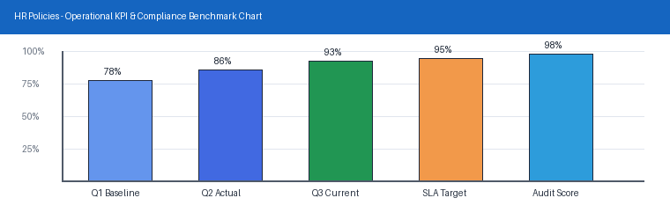
Page 4 of 4 | HR Knowledge Hub | HR Policies | SharePoint Online

